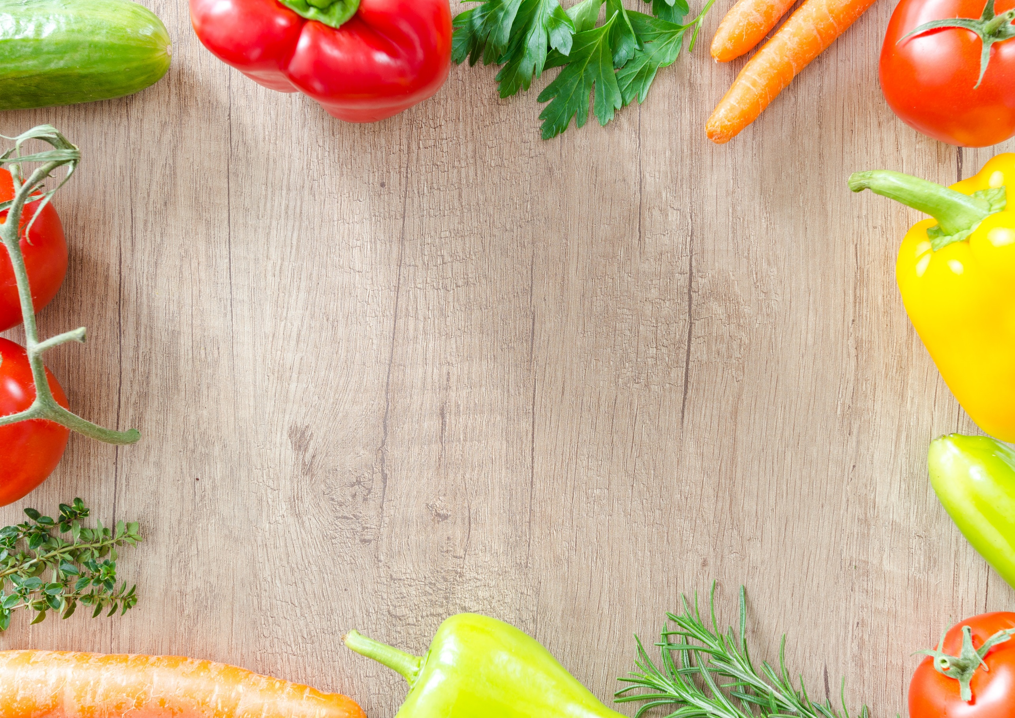
Daily Specials £3.20

Drinks
Tea 80p
Coffee 90p
Milky Coffee £1.30
Can of Pop 70p
Fruit Juice 70p
Bottled Water 60p
Flavoured Water 75p
Snacks
Slice of Cake from 90p
Crisps 30p
Chocolate Bar 60p
Chocolate Biscuit 30p
2 Slices of Toast 60p
Meals
Choice of hot and cold sandwiches £2.00
Toasties £2.00
Portion of Chips £1.20
Chips & Gravy £1.50
Cheesy Chips & Sauce £1.80

